**Salesforce CRM Project Documentation**

**HandsMen Threads: Elevating the Art of Sophistication in Men's Fashion**

**Submitted by:**

**Chadive Manasa**

**Institution/Organization:  
SMART BRIDGE**

**Program:**

**Salesforce Developer with Agentblazer Champion Program**

**Project Type:  
Salesforce CRM Implementation (Custom Objects, Flows, Apex, Automation, Reports)**

**Guided by:**

**Smart Bridge Educational Pvt.Lmt**

**Project Overview:**

HandsMen Threads, a forward-thinking fashion brand, has initiated a Salesforce CRM project aimed at transforming how the company manages customer interactions, inventory, and business operations. The objective is to develop a scalable, cloud-based CRM system that streamlines order processing, enhances customer engagement, and automates core business functions.

This Salesforce implementation includes the creation of custom objects for managing customers, products, orders, inventory, and marketing campaigns, tailored specifically to the fashion retail domain. The solution integrates automation through Flows and Apex Triggers to handle real-time order confirmations, loyalty program updates, and proactive stock level monitoring.

Additionally, batch Apex jobs have been implemented to process inventory restocks automatically on a daily basis, ensuring inventory accuracy and operational efficiency. Email templates and alerts further improve customer communication, while validation rules enforce data integrity at the UI level.

By combining point-and-click configuration with powerful custom Apex code, this project equips HandsMen Threads with a robust digital backbone, setting the stage for enhanced customer satisfaction, efficient inventory control, and long-term business scalability.

The **HandsMen Threads** Salesforce CRM implementation is a strategic initiative aimed at transforming the way the company manages customer interactions, order fulfilment, and inventory operations in the competitive fashion retail space. With a commitment to elevating customer experience and operational efficiency, the project introduces a custom CRM solution designed specifically for the brand's evolving needs. By leveraging the flexibility and scalability of the Salesforce Platform, this project integrates core business processes — such as order confirmation, stock control, and loyalty management — into a single, unified system.

The CRM system features custom-built data models, automated workflows, Apex triggers, and a user-friendly interface that empowers staff across departments — from Sales to Inventory to Marketing — to work seamlessly and access real-time insights. Features like automated email alerts, batch inventory updates, and loyalty status tracking offer a proactive approach to business operations, enabling HandsMen Threads to focus on customer satisfaction, timely service, and strategic growth. The overall solution is built with future readiness in mind, setting the stage for advanced analytics and intelligent automation in future phases.

**Objectives:**

The primary goal of the HandsMen Threads Salesforce CRM project is to create a tailored, end-to-end solution that addresses the unique needs of the fashion retail business. The key objectives of the project are:

* **Centralized Customer Management**:  
  To build a unified system for managing customer data, enabling personalized service, improved customer segmentation, and data-driven engagement strategies.
* **Automation of Business Processes**:  
  To automate routine tasks such as order confirmations, stock alerts, and loyalty program updates using Flows, Apex Triggers, and Scheduled Jobs — reducing manual work and increasing efficiency.
* **Inventory Optimization**:  
  To implement real-time inventory tracking and automated restocking mechanisms, ensuring optimal stock levels and minimizing operational disruptions.
* **Enhanced Data Integrity**:  
  To maintain data quality at every touchpoint by enforcing validation rules and logic-based restrictions at the user interface level.
* **Seamless Communication**:  
  To configure dynamic email templates and alerts that improve customer experience by providing timely and relevant updates on orders and loyalty programs.
* **Scalable CRM Architecture**:  
  To design a flexible Salesforce environment with reusable components (custom objects, permission sets, roles) that support future enhancements and business expansion.

Additionally, the project seeks to improve business agility through automation.  
Key workflows such as order confirmation, low-stock alerts, and loyalty updates are fully automated to reduce delays and minimize human errors.

Through the use of validation rules, record-triggered flows, and Apex logic, business rules are enforced directly within the system, ensuring that operations remain consistent, accurate, and scalable.

The end goal is to support a secure, intelligent, and future-ready CRM system that evolves alongside the business — helping HandsMen Threads maintain operational excellence and stand out in the competitive fashion landscape.

**Phase 1: Requirement Analysis & Planning**

This phase laid the foundation for the Salesforce CRM system by clearly defining the business requirements, system architecture, and security models to ensure scalability, usability, and compliance with organizational goals.

**1. Understanding Business Requirements:**

* HandsMen Threads required a CRM system tailored to the fashion industry to:
  + Store and manage customer, order, inventory, and product data.
  + Automate loyalty updates and stock notifications.
  + Enable real-time email communication for customer engagement.
  + Maintain high data quality standards and user-based security controls.

**2. Defining Project Scope and Objectives:**

In-Scope Deliverables:

* Creation of custom objects: HandsMen Customer, HandsMen Product, HandsMen Order, Inventory, Marketing Campaign.
* Custom tabs, layouts, and Lightning apps to support usability.
* Automation using Record-Triggered Flows, Scheduled Flows, Email Alerts, and Apex.
* Role-based access control with custom profiles and permission sets.
* Batch job for daily inventory sync.

**Out-of-Scope:**

* Integration with external e-commerce or POS systems (planned as future enhancement).

**3. Design: Data Model and Security Model**

**Data Model Design:**

Custom objects were created to align with business entities:

* HandsMen_Customer__c – Captures customer details including phone, email, and loyalty status.
* HandsMen_Product__c – Maintains product catalog and stock quantity.
* HandsMen_Order__c – Stores order records, including status and total amount.
* Inventory__c – Manages stock and restocking status.
* Marketing_Campaign__c – Tracks campaign activities.

**Key Relationships:**

* Lookup and Master-Detail relationships were defined between objects to maintain referential integrity and enable reporting.
  + E.g., HandsMen Order ↔ HandsMen Customer, Inventory ↔ Product

**Security Model Design:**

* **Profiles & Roles:**
  + Platform 1 profile (cloned from Standard User) for limited access users.
  + Roles created: Sales, Inventory, and Marketing under the CEO role hierarchy.
* **Permission Sets:**
  + Permission_Platform_1 with CRUD permissions on key custom objects.
* **Field-Level Security and Validation Rules:**
  + Ensured critical fields follow business logic, e.g., quantity limits, valid emails, etc.

**Phase 2: Salesforce Development – Backend & Configurations**

This phase focused on implementing the core functionality of the CRM through configuration and development. It included object creation, field definitions, automation logic, and backend Apex coding to support business operations.

**1. Environment Setup & DevOps Workflow**

* A Salesforce **Developer Org** was created via [developer.salesforce.com](https://developer.salesforce.com/signup).
* Users verified their accounts, defined passwords, and accessed the **Salesforce Setup** environment.
* Development was managed directly within Salesforce using the **Developer Console**, Flows, and Setup menu.

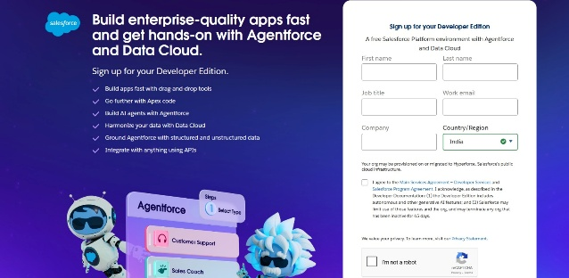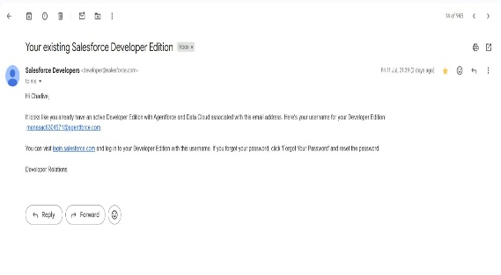

**2. Custom Object & Field Configuration**

* Custom objects were created to represent real-world business entities:

| **Object Name** | **Key Fields** | **Notes** |
| --- | --- | --- |
| HandsMen Customer | Email, Phone, Loyalty Status (Picklist) | Includes formula field Full Name |
| HandsMen Product | Stock Quantity | Used in inventory updates |
| HandsMen Order | Auto-numbered Order ID, Total Amount, Status | Related to customer and product |
| Inventory | Auto-numbered Inventory ID, Stock Quantity | Master-detail with product |
| Marketing Campaign | Auto-numbered Campaign ID | Lookup to customer |

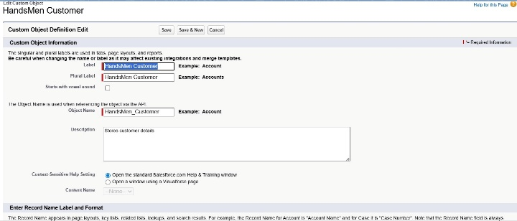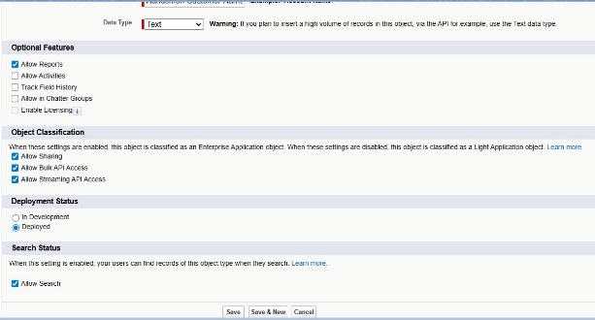

**Relationships Used:**

* Lookup:
  + Order ↔ Customer, Product ↔ Order, Marketing Campaign ↔ Customer
* Master-Detail:
  + Inventory ↔ Product

**3. Validation Rules**

| Object | Rule Name | Logic | Error Message |
| --- | --- | --- | --- |
| HandsMen Order | Total Amount | Total_Amount__c <= 0 | "Please Enter Correct Amount" |
| Inventory | Stock Quantity | Stock_Quantity__c <= 0 | "The inventory count is never less than zero." |
| HandsMen Customer | Email | NOT CONTAINS(Email, "@gmail.com") | "Please fill Correct Gmail" |

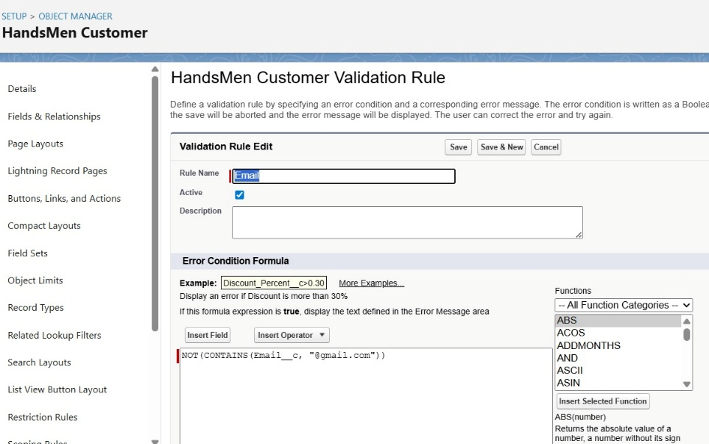

**4. Profiles, Roles, and Permission Sets**

* Profile: Platform 1 cloned from Standard User, granted object-level permissions for Product and Inventory.
* Roles: Sales, Inventory, and Marketing created under the CEO role hierarchy to define data visibility.
* Users: Created for Niklaus Mikaelson (Sales) and Kol Mikaelson (Inventory) with Platform licenses and assigned profiles.
* Permission Set: Permission_Platform_1 to grant extra permissions on Customer and Order objects.

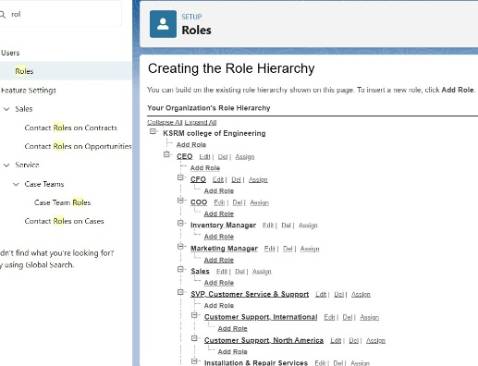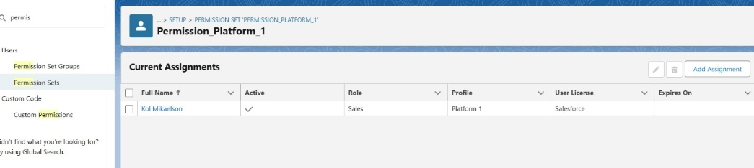

**5. Email Templates & Alerts**

Three Classic Email Templates were configured:

| Template Name | Description |
| --- | --- |
| Order Confirmation Email | Sent to customer when an order is confirmed |
| Low Stock Alert | Sent to Inventory Manager for low stock |
| Loyalty Program Email | Sent when customer loyalty is updated |

**Email Alerts** were created and linked to flows to trigger these templates automatically.

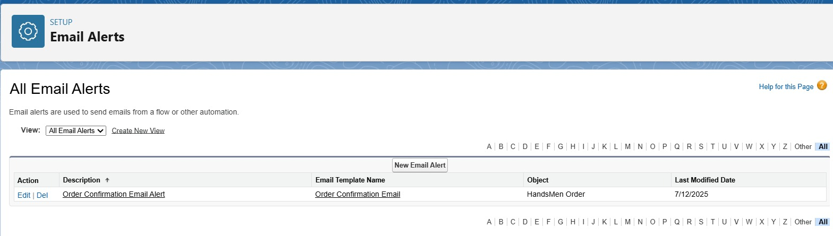

**6. Apex Classes & Triggers**

* OrderTriggerHandler (Class)
* Validates order quantity based on status.
* OrderTrigger (Trigger)
* Fires on before insert and before update for HandsMen_Order__c.

**7. Asynchronous Apex: Inventory Batch Job**

Class: InventoryBatchJob

Implements Database.Batchable and Schedulable to:

* Query products with low stock
* Refill stock quantities by +50
* Schedule daily at midnight via:

“ System.schedule('Daily Inventory Sync', '0 0 0 * * ?', new InventoryBatchJob()); “

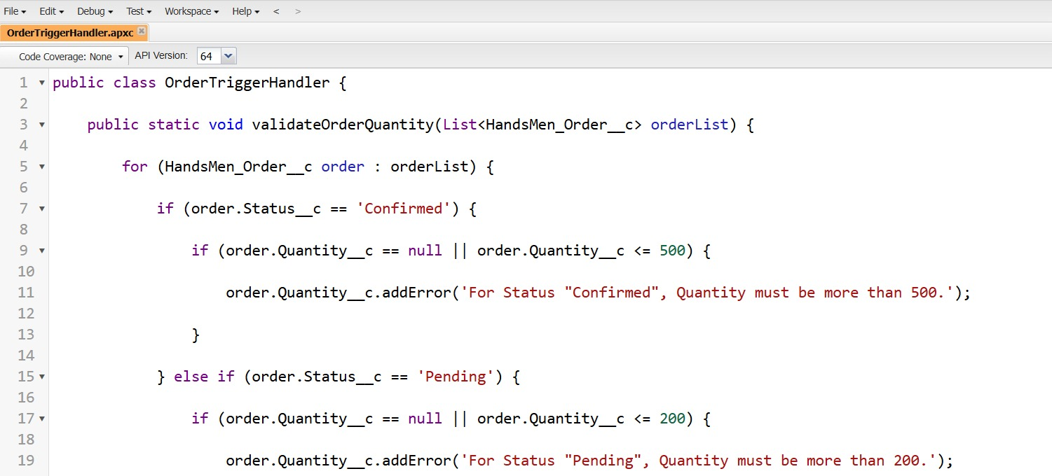

**Phase 3: UI/UX Development & Customization**

In this phase, the focus was on creating an intuitive and responsive user interface using Salesforce Lightning tools. The goal was to ensure that end users—such as sales reps, inventory managers, and marketing staff—could easily navigate the system and perform daily tasks efficiently.

**1. Lightning App Setup via App Manager**

* **App Name**: HandsMen Threads
* **Navigation Items Included**:
  + HandsMen Customer
  + HandsMen Order
  + Inventory
  + HandsMen Product
  + Marketing Campaign
  + Reports & Dashboards
  + Accounts & Contacts
* Assigned to: System Administrator profile

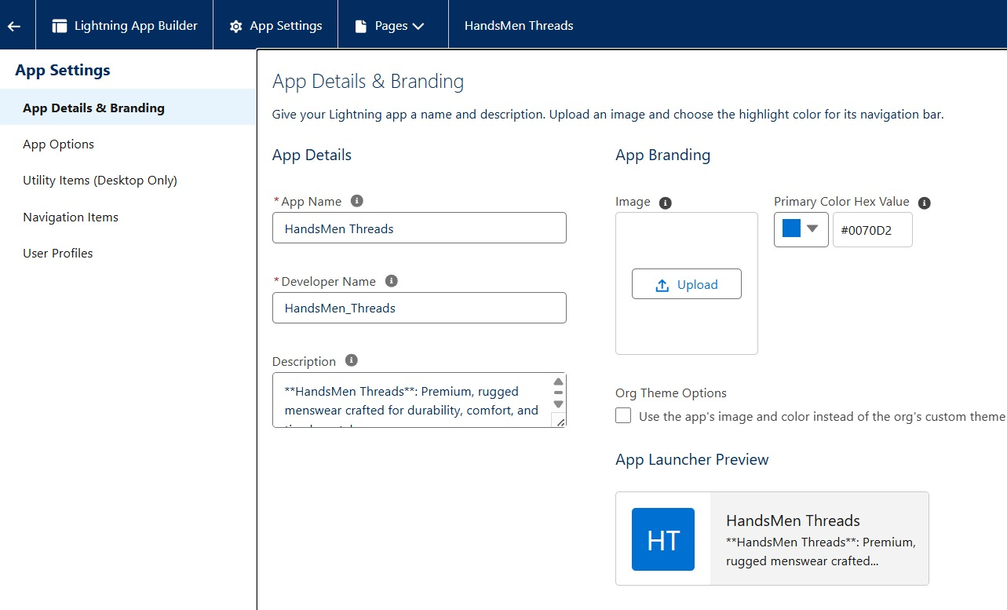

**2. Tabs & Layouts**

* Custom Tabs were created for each object to make them accessible via the Lightning App.
* **Page Layouts** were modified to include relevant fields, related lists, and actions.
* **Dynamic Forms** were optionally used to show/hide fields based on status or role (optional for bonus).

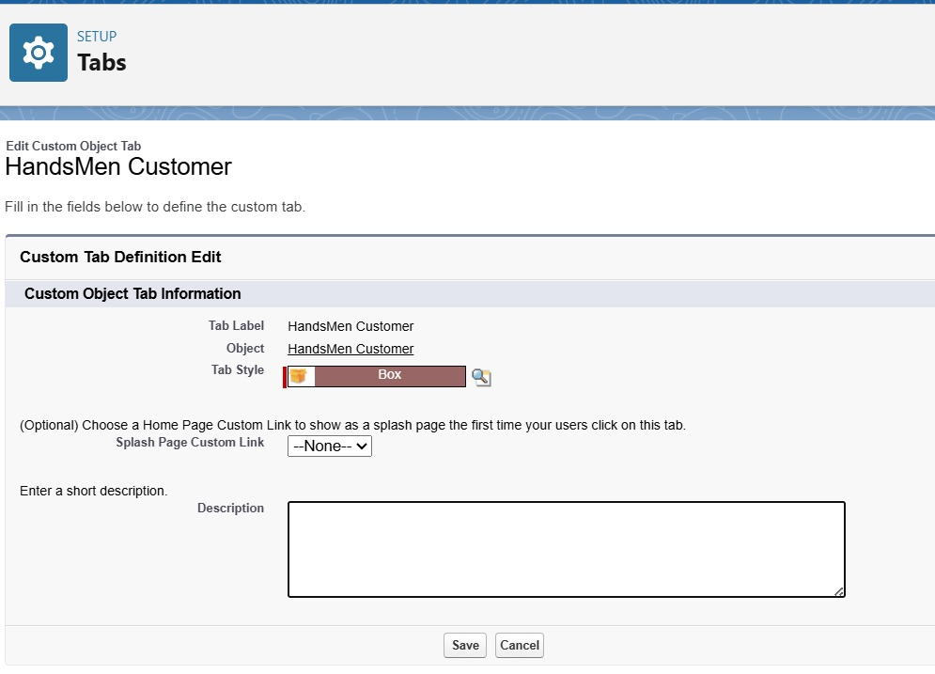

**3. User Management**

Two users were created with real-world role simulation:

* Niklaus Mikaelson – Sales Role
* Kol Mikaelson – Inventory Role  
  Each user was assigned:
  + Role (Sales or Inventory)
  + Profile (Platform 1)
  + Permission Set (Permission_Platform_1)

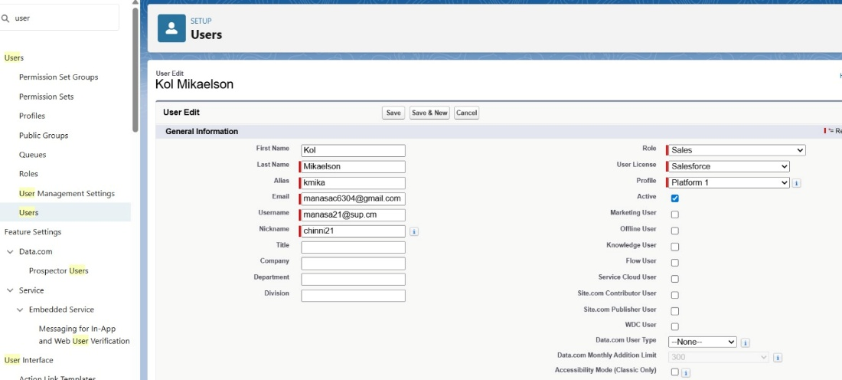

**4. Reports and Dashboards**

While not detailed, the app supports creation of:

* Reports to monitor Orders, Stock Levels, and Customer Loyalty
* Dashboards to visualize key metrics such as:
  + Orders by Status
  + Low Stock Alerts
  + Loyalty Tier Distribution

**5. Lightning Pages**

* Custom record pages were created and assigned for each object using Lightning App Builder.
* These pages incorporated:
  + Related Lists
  + Quick Actions
  + Embedded Reports (if needed)

This UI/UX phase ensures that your users have a professional, clean, and productive interface experience—tailored to their business roles.

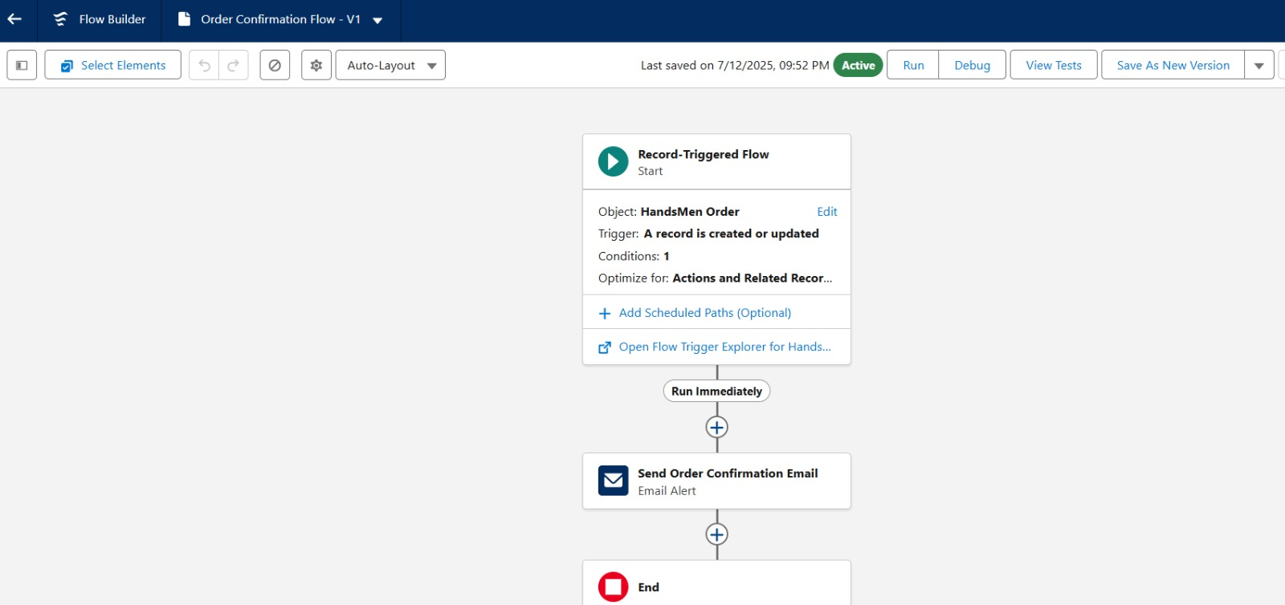

**Phase 4: Data Migration, Testing & Security**

This phase focused on ensuring that the system is secure, data is accurate, and every feature functions as expected. Special attention was given to access control, data validation, and thorough testing before production deployment.

**1. Data Loading Process**

Data migration and test data setup were performed using Salesforce tools:

* **Data Import Wizard** – Used for loading data into simple objects like HandsMen Customer.
* **Data Loader** – Used for bulk importing data into related or custom objects such as Orders, Inventory, and Products.

**2. Field History Tracking, Duplicate Rules & Matching Rules**

* **Field History Tracking** was enabled for key objects (like Order and Inventory) to monitor changes in important fields such as Stock Quantity and Order Status.
* **Duplicate Rules** were configured on HandsMen Customer (based on email field) to prevent duplicate records.
* **Matching Rules** ensured proper identification of existing records during import and creation.

**3. Security Settings: Profiles, Roles, Permission Sets, and Sharing**

**Profiles:**

* Platform 1 profile provided controlled access to custom objects.
* Field-level security enforced visibility only for relevant fields.

**Roles:**

* Role hierarchy defined as:
  + CEO
    - Sales
    - Inventory
    - Marketing

This ensured data access flowed upward based on hierarchy.

**Permission Sets:**

* Permission_Platform_1 provided additional CRUD permissions on objects like Order and Customer without modifying the base profile.
* Assigned to users based on business requirements.

**Sharing Rules:**

* Public Read/Write sharing model used for development.
* Manual sharing and custom rules considered for future scalability.

**4. Testing Approach**

Each automation and feature was tested using sample data:

| **Feature Tested** | **Input Condition** | **Expected Output** |
| --- | --- | --- |
| Order Creation Flow | Order with Status = "Confirmed" | Confirmation Email triggered |
| Low Stock Alert Flow | Inventory with stock < 5 | Email sent to Inventory Manager |
| Loyalty Program Flow | Customer with Purchase > 1000 | Loyalty Status updated to "Gold" |
| Validation Rule – Order Amount | Total Amount <= 0 | Error: “Please Enter Correct Amount” |
| Trigger – Quantity Check | Quantity = 100 and Status = "Confirmed" | Error: “Quantity must be more than 500” |
| Batch Job Execution | Product Stock < 10 | Auto-restocking by +50 units |

Test Classes were created for all Apex Classes and Triggers.

Test coverage ensured was above the 75% Salesforce requirement.

**Phase 5: Deployment, Documentation & Maintenance**

This final phase ensured that the Salesforce CRM system was safely deployed to the production environment, well-documented for future reference, and set up with a clear maintenance and support plan.

**1. Deployment Strategy**

* **Change Sets** were used to migrate metadata from the Developer Org to Production.
* Included:
  + Custom Objects, Fields, Page Layouts
  + Flows, Email Templates, Validation Rules
  + Apex Classes and Triggers
* Pre-deployment validations ensured no metadata conflicts or errors.

**2. Documentation Approach**

A structured **Solution Design Document (SDD)** was prepared including:

* Custom Object Model with field details and data types
* ERD (Entity Relationship Diagram) outlining object relationships
* List of Validation Rules, Flows, Apex Classes, and Automation
* Test Case Scenarios with screenshots and expected outcomes
* Troubleshooting steps for common issues

**3. Troubleshooting & Maintenance Strategy**

* **Post-Go-Live Monitoring**:
  + Regularly checking flow execution logs, Apex errors, and data accuracy
  + Monitoring scheduled jobs such as InventoryBatchJob
* **Error Handling**:
  + Proper error messages implemented in validation rules and Apex triggers
  + Debug logs used during batch failures or flow issues
* **User Feedback Loop**:
  + Continuous support provided to users for adjustments
  + Changes tracked via Sandbox → UAT → Production deployment cycle

**4. Knowledge Transfer & Change Management**

* Admins and end-users were trained on:
  + Navigation through the Lightning App
  + Using record forms, dashboards, and reports
  + Managing users and roles in real-time
* A knowledge base of FAQs and process flows was shared internally for reference.

**Future Enhancements**

While the current Salesforce CRM implementation for HandsMen Threads provides a solid foundation, several future enhancements have been identified to further optimize business processes, enrich customer experiences, and support organizational growth:

**1. Chatbot Integration**

* Implement an AI-powered chatbot (e.g., Salesforce Einstein Bot or third-party integration) to handle customer inquiries in real time.
* Use cases include order tracking, FAQs, loyalty program inquiries, and support ticket creation.

**2. AI-Powered Product Recommendations**

* Leverage Salesforce Einstein Recommendations to suggest products to customers based on their purchase history and preferences.
* Improve upselling and cross-selling strategies.

**3. Advanced Analytics & Forecasting**

* Enable Einstein Analytics (CRM Analytics) to gain deeper insights into sales trends, customer lifetime value, and inventory forecasting.
* Automate report generation and executive dashboards.

**4. Mobile Optimization**

* Enhance the Salesforce Mobile App interface for sales reps and inventory managers on the go.
* Enable push notifications for low stock, order approvals, and campaign updates**.**

**5. Customer Feedback & Surveys**

* Use Salesforce Surveys or integrate external tools like Typeform to gather post-purchase feedback.
* Automatically trigger surveys via Flow after order confirmation.

**6. Enhanced Role-Based Access & Territory Management**

* Define territory models for better segmentation of sales regions.
* Apply advanced sharing rules and criteria-based access control for field-level security.

**7. CI/CD and Sandbox Management**

* Introduce DevOps Center for version control, deployment pipelines, and easier collaboration among developers/admins.
* Set up multiple Sandboxes (Developer, UAT, Full Copy) for safer testing.

**Conclusion**

The implementation of Salesforce CRM for **HandsMen Threads** marks a significant milestone in the organization’s digital transformation journey. With a strong emphasis on automation, data accuracy, and user-centric design, this project has laid a robust foundation for optimized customer management, streamlined order workflows, and proactive inventory control.

This CRM solution was built from the ground up using Salesforce’s powerful tools — including custom objects, flows, Apex triggers, scheduled jobs, and role-based access controls — all tailored specifically to the fashion and retail domain. By replicating real-world business logic into Salesforce:

* **Customer engagement** has been enhanced through automated email communications, order confirmations, and loyalty updates.
* **Operational efficiency** has improved with stock monitoring, batch inventory updates, and clear data validation checks.
* **User roles and responsibilities** are now clearly mapped, ensuring the right people access the right data at the right time.
* **Scalability and maintenance** have been carefully considered, with reusable components and organized documentation making future updates seamless.

Each project phase — from planning to deployment — has been executed with clear objectives, thorough testing, and alignment with best practices. The system is now well-equipped to support:

* Business growth through smarter sales and marketing insights
* Real-time decision-making via dashboards and reports
* A more professional and responsive customer experience

In essence, Salesforce has not only automated tasks but also empowered the organization with data-driven capabilities. This ensures that **HandsMen Threads** is better positioned to respond to market demands, build stronger customer relationships, and scale confidently in the ever-evolving fashion industry.